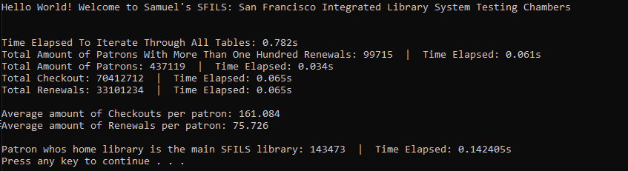

My findings were very basic, as I wasn’t exactly sure what to look for here. I was interested in the average checkouts versus renewals. It seems checking out is far more popular than renewals, San Francisco readers must be fast I guess. What I thought was interesting was that it was faster to fetch the entire table, than the same table where it only returns Patrons that have more than 100 renewals on their account. Though this makes sense than you think of it, there is some sort of conditional for each row, so there are more steps the iterate through the table.

I think in terms of findings I would be more interested if this SFILS table set provided more information, renewal history, checkout history, book stock, condition of book etc. I guess what I am trying to say is I'm more interested in the books, and how patrons would interact with them, than the patrons themselves. So I’m sorry if I don’t have as many findings as you were hoping for, I truly wasn’t sure what you were looking for.

Maybe that could be a good bag of tasks, given your assignment 01 integration, please find x information. Then our task can be to write the appropriate sql statement for said information. I truly drew a blank when trying to come with things to look for.

